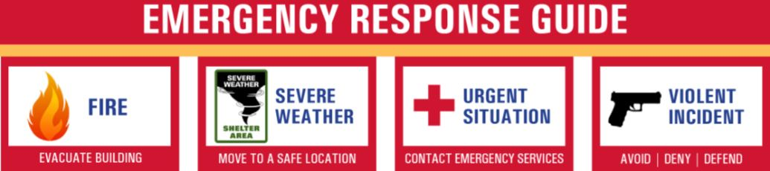

MAJOR INJURY……………911
PLACER COUNTY SHERIFF…………..530-886-5375
FORESTHILL FIRE DEPARTMENT…530-367-2465

ANIMAL CONTROL…………….530-889-7315
FDLL PRESIDENT
Alex Torres 916-710-1646

FDLL Safety Officer
Chase Teppola 916-224-8459

